**DAILY ONLINE ACTIVITIES SUMMARY**

|  |  |  |  |  |  |  |  |
| --- | --- | --- | --- | --- | --- | --- | --- |
| **Date:** | **13-06-2020** | | | | **Name:** | **Rani M.D** | |
| **Sem & Sec** | **6th - B** | | | | **USN:** | **4AL17CS075** | |
| **Online Test Summary** | | | | | | | |
| **Subject** | **PAP** | | | | | | |
| **Max. Marks** | **30** | | **Score** | | | **25** | |
| **Certification Course Summary** | | | | | | | |
| **Course** | **TCS Edge Carrier** | | | | | | |
| **Certificate Provider** | | **TCS** | | **Duration** | | | **15 days** |
| **Coding Challenges** | | | | | | | |
| **Problem Statement:2 Java program 1 Python program 1C program** | | | | | | | |
| **Status: Executed** | | | | | | | |
| **Uploaded the report in GitHub** | | | | **yes** | | | |
| **If yes Repository name** | | | | Daily Status | | | |
| **Uploaded the report in slack** | | | | **Yes** | | | |

Test Details: (Attach the snapshot and briefly write the report for the same)

Fourth IA Test:PAP

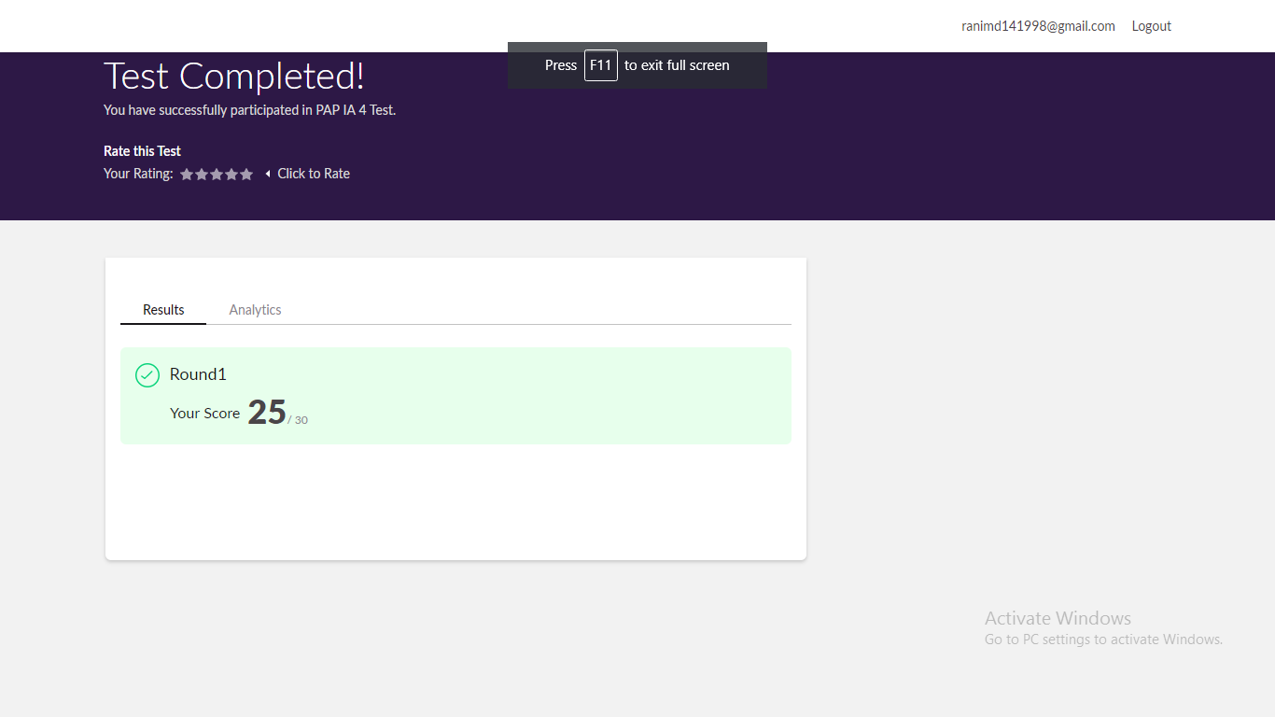

Certification Course Details: (Attach the snapshot and briefly write the report for the same)

1.

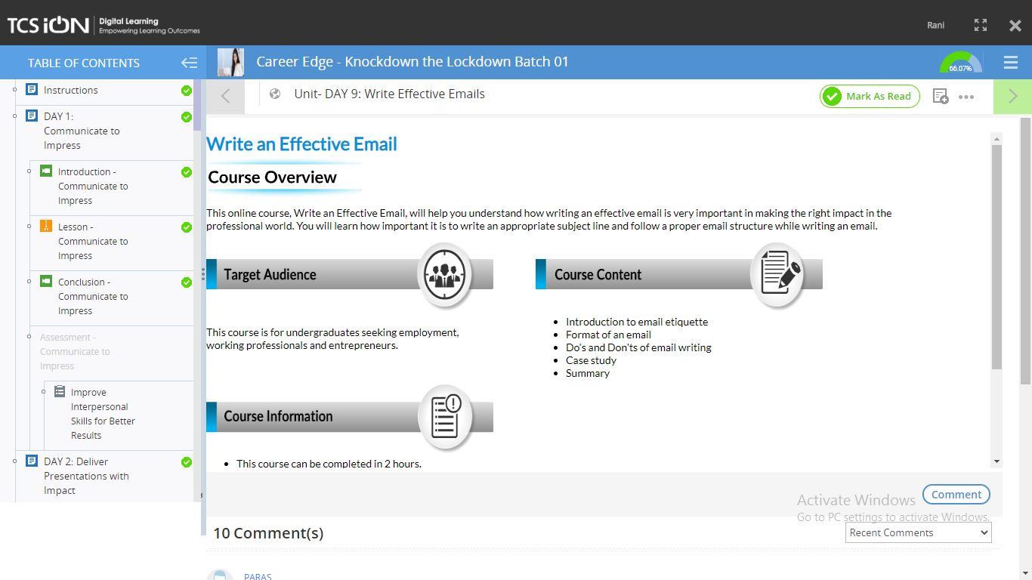

2.

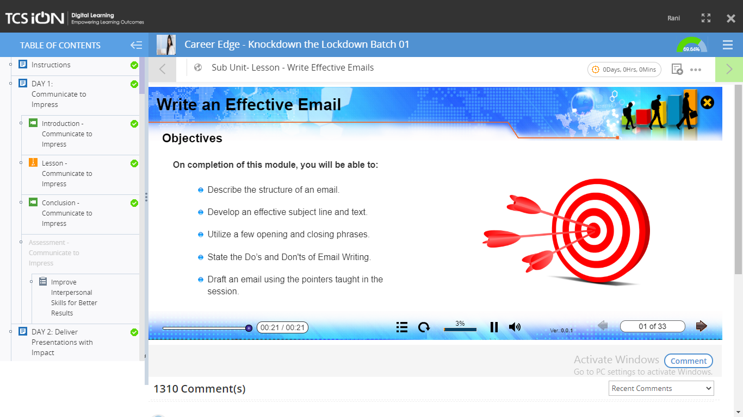

3.

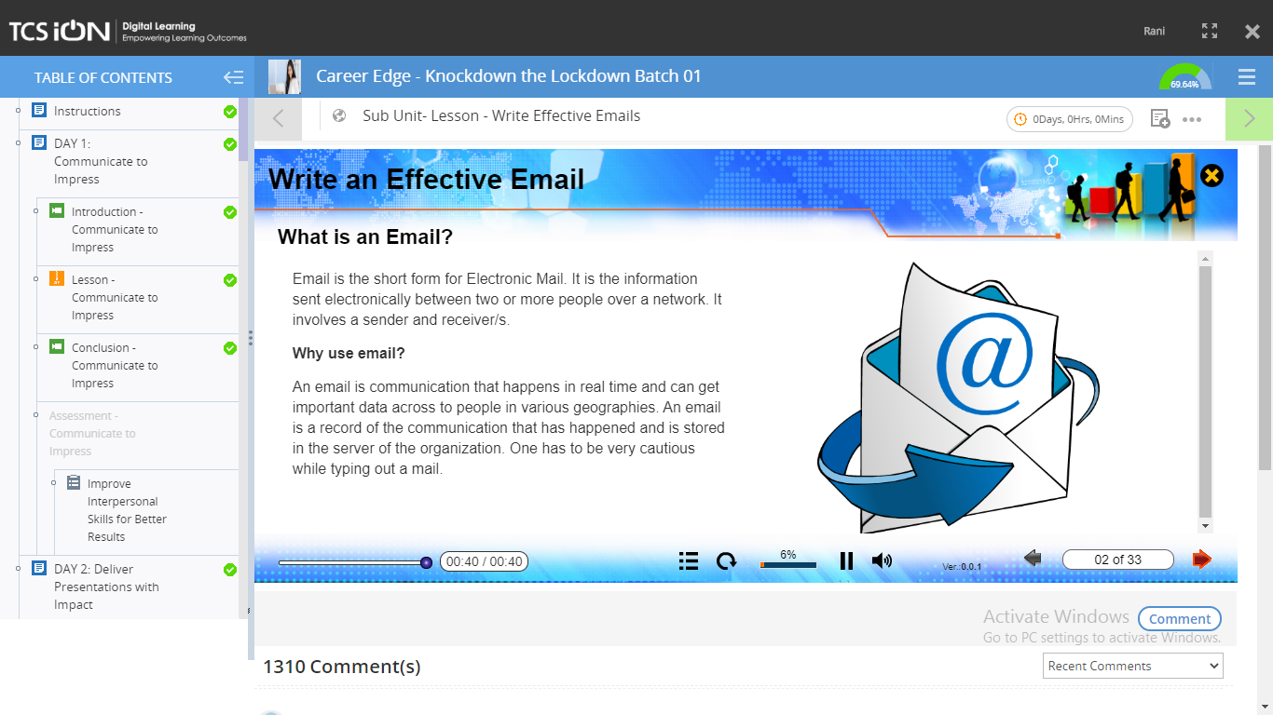

4.

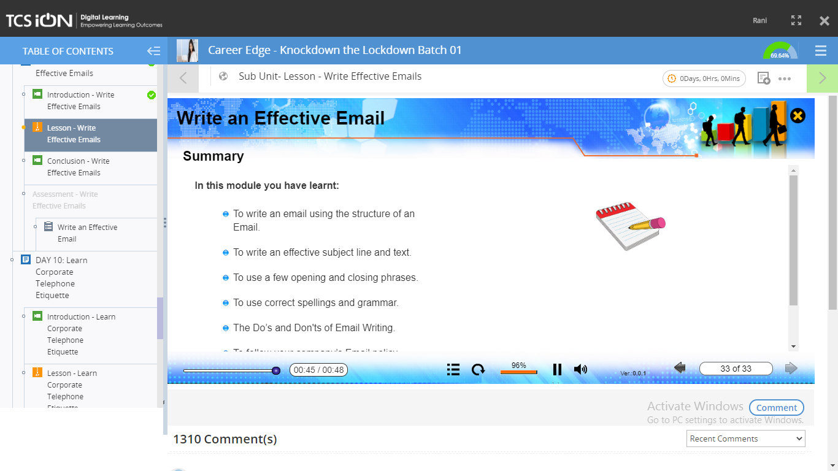

5.

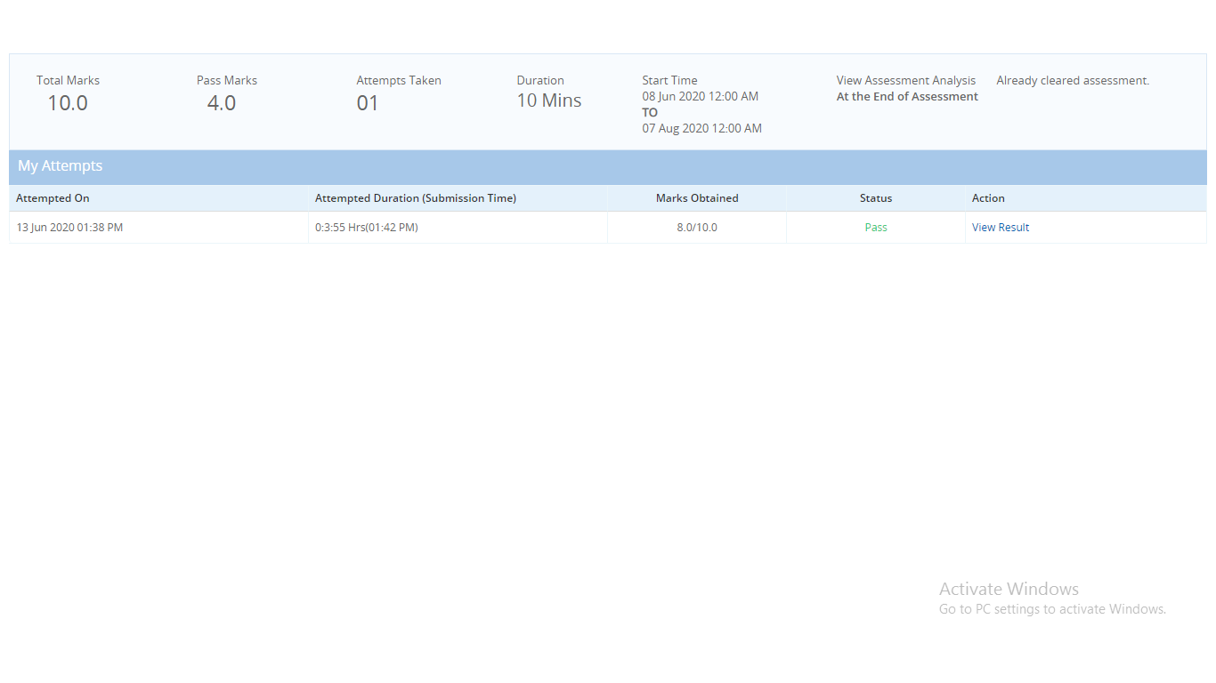Coding Challenges Details: (Attach the snapshot and briefly write the report for the same

Output screen shots

1. Write a C Program to calculate Electricity Bill 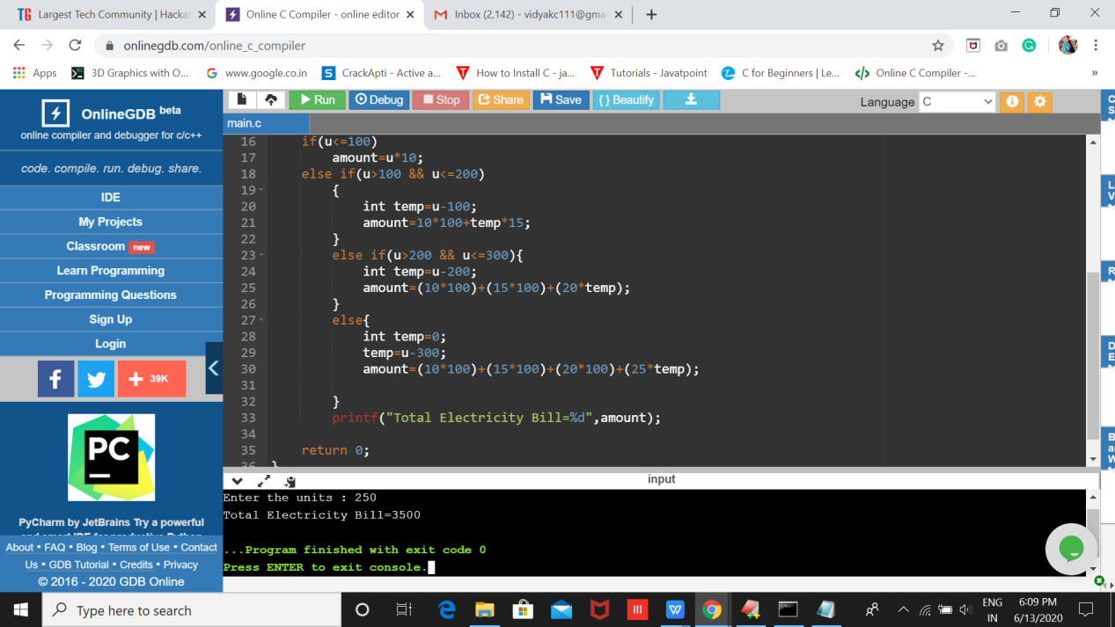

2.Write java program to find the first non repeated character of a given String

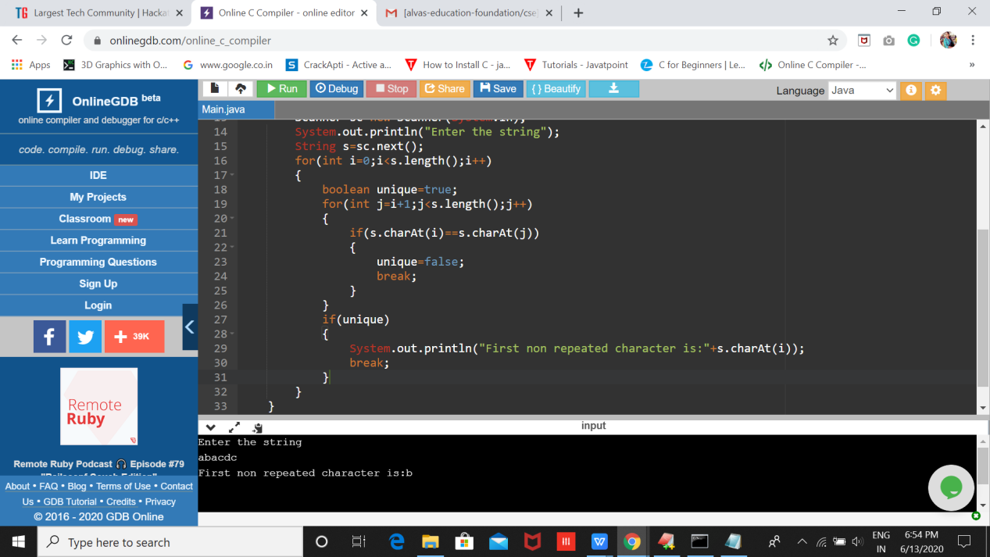

3.Write a Java Program to determine whether a given matrix is a sparse matrix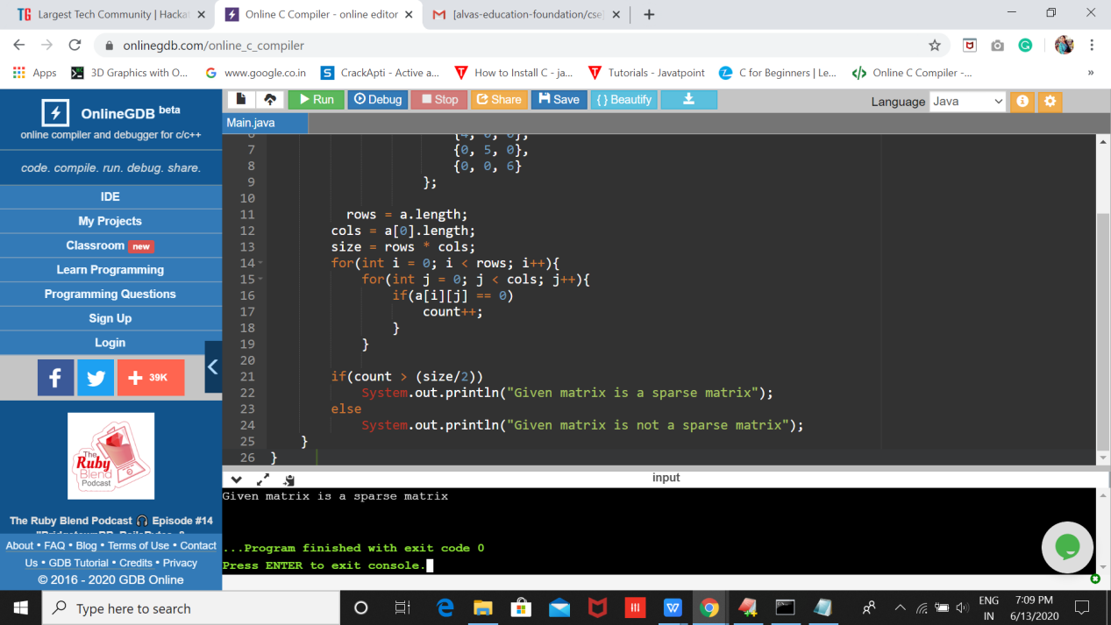

4.Write a python program to print the following pattern.

